Model Report 2012 & 2016 W/out previous vote

Accuracy : 0.9231

AUC Score (Test): 0.973656

education: 0.23421327769756317

race: 0.1013922467827797

gender: 0.08123496919870377

ideology: 0.07813943922519684

registered: 0.07186463475227356

age: 0.06405814737081528

president_app: 0.05993276089429855

imiss_c: 0.053716812282800674

imiss_d: 0.05329301208257675

religion: 0.050602544099092484

imiss_f: 0.043393198400735855

imiss_a: 0.038660530000925064

party: 0.036720745265483856

imiss_b: 0.03277764469385147

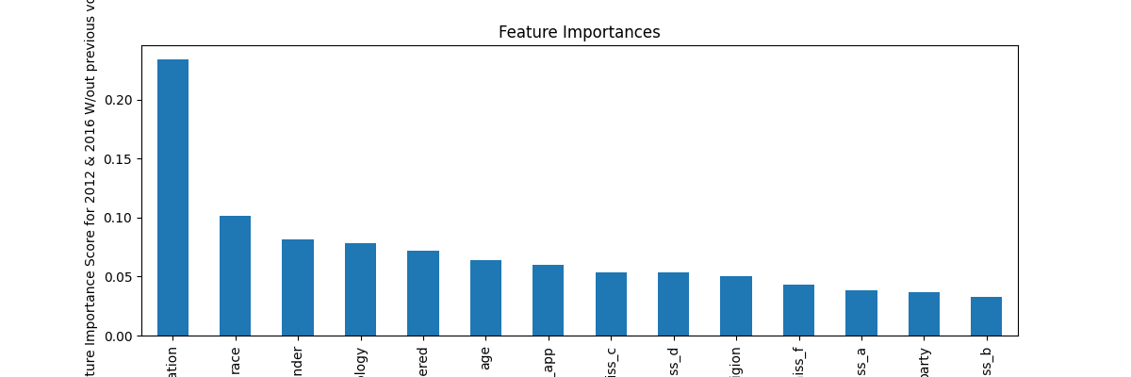

Model Report 2012 & 2016 W/ previous vote

Accuracy : 0.9332

AUC Score (Test): 0.980343

voted_previous: 0.5592079162597656

education: 0.07555561512708664

race: 0.04545144736766815

gender: 0.041641004383563995

ideology: 0.034398406744003296

age: 0.030779577791690826

imiss_d: 0.028382353484630585

president_app: 0.026145434007048607

imiss_f: 0.025907112285494804

imiss_c: 0.022337842732667923

imiss_a: 0.022174319252371788

religion: 0.02188519574701786

party: 0.018219327554106712

imiss_b: 0.017896132543683052

year: 0.016795286908745766

registered: 0.013222912326455116

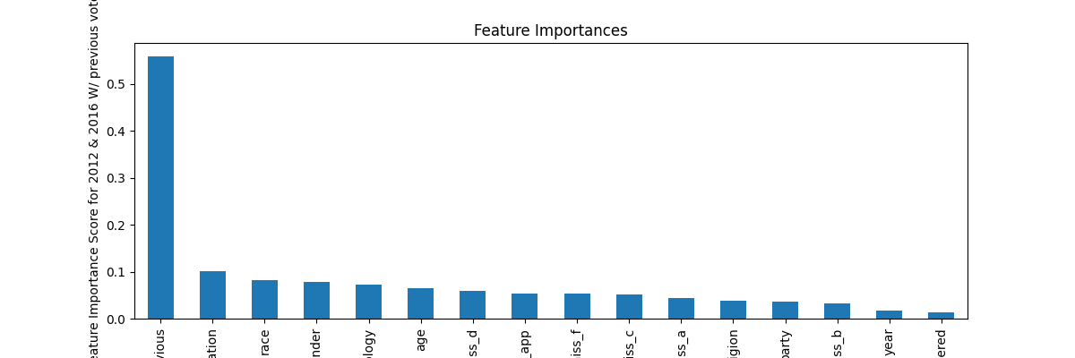

Model Report 2016 W/ previous vote

Accuracy : 0.9698

AUC Score (Test): 0.993916

voted_previous: 0.17861789464950562

RIGGED_SYSTEM_1_2016: 0.06278690695762634

race: 0.04052712395787239

imiss_a: 0.03898245468735695

president_app: 0.03152509778738022

ambornin_2016: 0.030551228672266006

fair_people_2016: 0.029805496335029602

futuretrend_2016: 0.022845495492219925

RIGGED_SYSTEM_4_2016: 0.02227565087378025

imiss_l_2016: 0.021772025153040886

US_respect_2016: 0.01843550242483616

imiss_r_2016: 0.018035829067230225

imiss_o_2016: 0.0179570484906435

RIGGED_SYSTEM_2_2016: 0.01793619990348816

RIGGED_SYSTEM_3_2016: 0.017923489212989807

helpful_people_2016: 0.017798177897930145

amgovt_2016: 0.017796751111745834

wealth_2016: 0.015780948102474213

trust_people_2016: 0.015345769934356213

track_2016: 0.015153945423662663

imiss_p_2016: 0.015091225504875183

education: 0.01383022777736187

imiss_b: 0.013570643030107021

RIGGED_SYSTEM_5_2016: 0.013092082925140858

amenglish_2016: 0.012928151525557041

values_culture_2016: 0.012221193872392178

persfinretro_2016: 0.012163296341896057

ideology: 0.011891350150108337

imiss_g_2016: 0.011465689167380333

imiss_m_2016: 0.01126190647482872

amwhite_2016: 0.01081598550081253

imiss_d: 0.010775478556752205

imiss_q_2016: 0.010738992132246494

imiss_x_2016: 0.01058956142514944

imiss_y_2016: 0.010531687177717686

party: 0.010330196470022202

amcit_2016: 0.009710593149065971

RIGGED_SYSTEM_6_2016: 0.009452643804252148

age: 0.009188702329993248

trustgovt_2016: 0.008432174101471901

amlived_2016: 0.008369944989681244

amchrstn_2016: 0.008346029557287693

amdiverse_2016: 0.008127190172672272

imiss_u_2016: 0.008037803694605827

Americatrend_2016: 0.007484166882932186

imiss_c: 0.007096804678440094

gender: 0.007037878502160311

religion: 0.006719968281686306

imiss_h_2016: 0.0066055110655725

imiss_f: 0.0064270091243088245

imiss_e_2016: 0.0064130802638828754

imiss_j_2016: 0.0064011067152023315

imiss_t_2016: 0.006274415645748377

imiss_k_2016: 0.005752736236900091

imiss_i_2016: 0.005596754606813192

econtrend_2016: 0.0052652787417173386

imiss_n_2016: 0.005207735113799572

imiss_s_2016: 0.004901852924376726

registered: 0.0

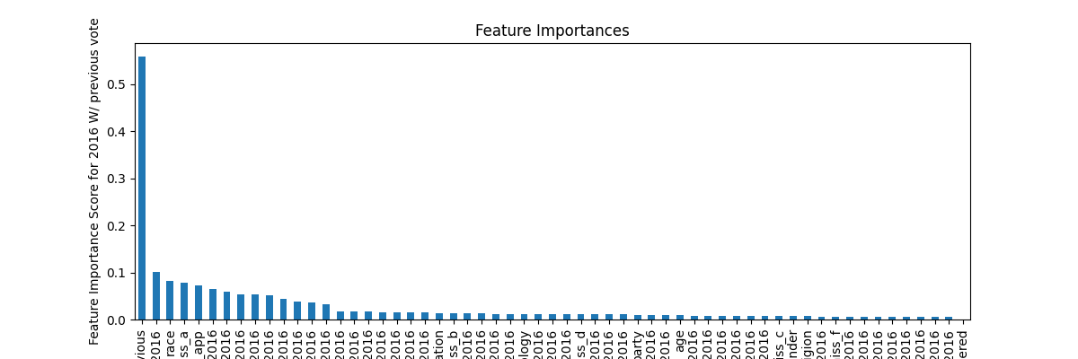

Model Report 2016 W/out previous vote

Accuracy : 0.9698

AUC Score (Test): 0.993550

RIGGED_SYSTEM_1_2016: 0.11392302811145782

imiss_a: 0.058442600071430206

race: 0.054284993559122086

ambornin_2016: 0.03649532422423363

imiss_l_2016: 0.03255801647901535

RIGGED_SYSTEM_4_2016: 0.03075798973441124

president_app: 0.027998173609375954

trust_people_2016: 0.02748771198093891

helpful_people_2016: 0.022493621334433556

RIGGED_SYSTEM_5_2016: 0.02211693301796913

futuretrend_2016: 0.022054439410567284

RIGGED_SYSTEM_3_2016: 0.02021230384707451

education: 0.02015003003180027

amgovt_2016: 0.01912768930196762

imiss_o_2016: 0.018816327676177025

persfinretro_2016: 0.018789537250995636

US_respect_2016: 0.018704529851675034

RIGGED_SYSTEM_2_2016: 0.018243014812469482

ideology: 0.016983147710561752

amwhite_2016: 0.01672786846756935

values_culture_2016: 0.01667460985481739

track_2016: 0.016508253291249275

fair_people_2016: 0.015905287116765976

imiss_y_2016: 0.015247332863509655

imiss_p_2016: 0.015240232460200787

amenglish_2016: 0.015025979839265347

imiss_r_2016: 0.014702394604682922

party: 0.013567104004323483

imiss_q_2016: 0.013414736837148666

amlived_2016: 0.012694509699940681

amcit_2016: 0.01268294919282198

age: 0.012427217327058315

imiss_m_2016: 0.012049607001245022

imiss_x_2016: 0.011848392896354198

wealth_2016: 0.011688771657645702

imiss_d: 0.01082391757518053

gender: 0.010641664266586304

amchrstn_2016: 0.010503211058676243

RIGGED_SYSTEM_6_2016: 0.009622924029827118

imiss_g_2016: 0.009539349004626274

imiss_c: 0.009456608444452286

imiss_b: 0.009342585690319538

amdiverse_2016: 0.009293668903410435

imiss_u_2016: 0.008761522360146046

imiss_h_2016: 0.00808410719037056

imiss_i_2016: 0.007563468534499407

Americatrend_2016: 0.007490464951843023

trustgovt_2016: 0.007344451732933521

imiss_e_2016: 0.007067172788083553

imiss_j_2016: 0.007029925938695669

religion: 0.006926285102963448

imiss_k_2016: 0.006275242194533348

econtrend_2016: 0.006084734108299017

imiss_n_2016: 0.005720918066799641

imiss_f: 0.005695193540304899

imiss_t_2016: 0.005433875601738691

imiss_s_2016: 0.0052541024051606655

registered: 0.0

